
www.orlandosewcial.com

Canvas Tote Bag

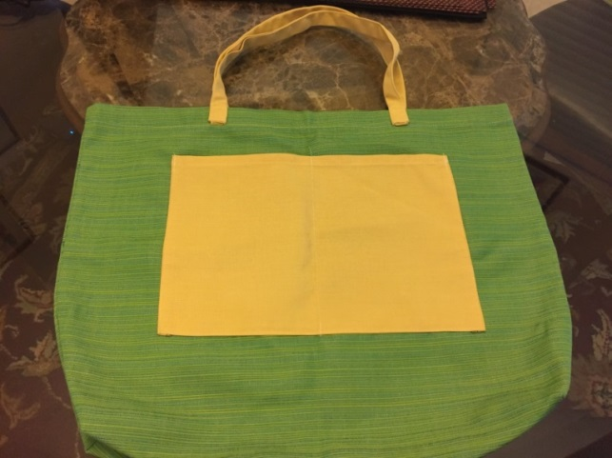
Material:
- Cut out a piece that is 20" X 34"
- Straps: Two 3” X 22”
- Pockets: Two 13” X 10”
Instructions:
- Fold the canvas in half - it is now 20” X 17”
- The fold is going to be the bottom.
- Pockets:
  - Fold ¼”, pin all 4 raw sides and sew
  - Center and place the pockets 5.5” from the top
  - Pic and sew both pockets on the front and back of the canvas. Optional to add a divider in one of the pockets. Remember to reinforce the ends
- Top:
  - At the top, fold ¼” towards the wrong side
  - Pin and iron or sew (for canvas material)
  - Double-fold another ½”, pin, and hem
- Handles:
  - Center the strap about 8" apart, fold in the rough edges and line up to the 1" fold of the top of the bag.
  - Pin and sew a box shape with an X cross inside to reinforce the handle
- French Seam the sides: http://www.craftsy.com/blog/2013/05/seam-series-how-to-sew-a-french-seam/
  - Pin wrong sides together and sew 1/4″ seam allowance.
- Turn the bag to get the right side facing together
- Sew with seam allowance of 1/2″ trapping the original seam and allowance in the fold.
- Box look: Make a triangle at the bottom of the bag, pin, mark and sew 2” from the bottom
- Bottom Corner: On the bottom corners of your bag, you're going to pinch the corners and then sew across like shown. Pin and sew about 2" across the corners. Repeat on the other bottom corner of the bag.
- This gives your bag more of a bottom/volume.
- Turn the bag right-side out!

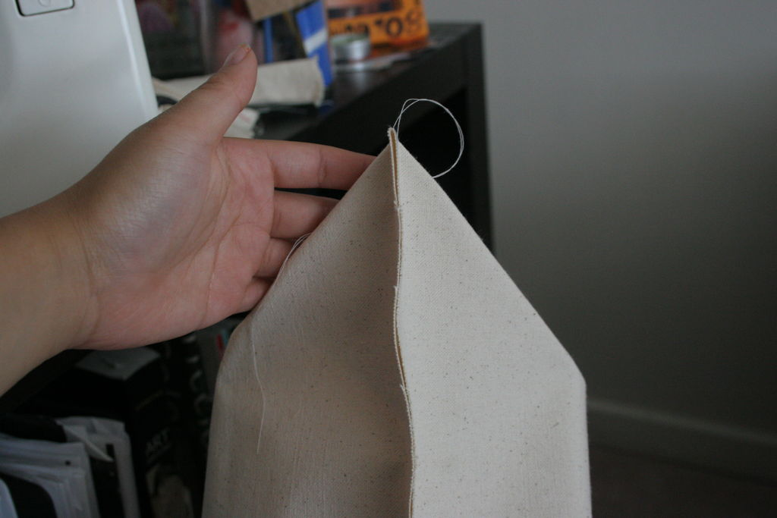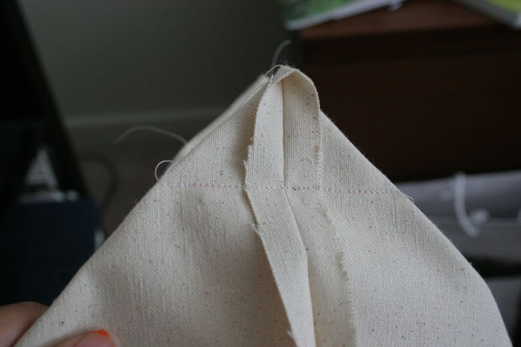

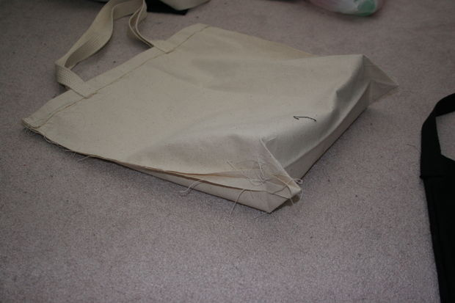

YouTube video for something similar: https://www.youtube.com/watch?v=QNrbP7xxH8s

