
www.orlandosewcial.com

Quilted Table Runner – Flip & Sew

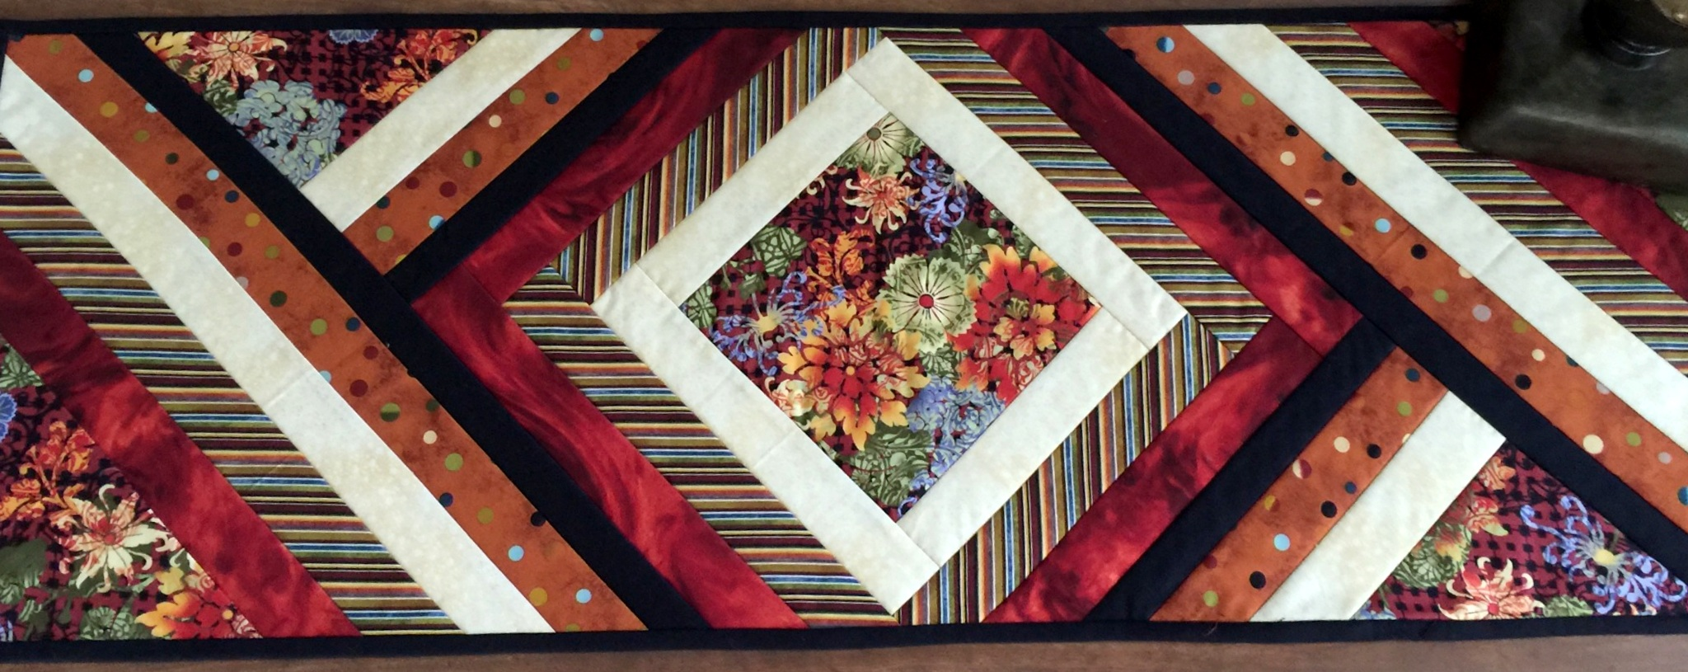

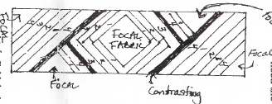
This table runner is made on a foundation of batting and backing. You will need the following:

Material
- One 16" X WOF strip of EACH batting and backing
- One 7 ½ " square of focal fabric (fussy cut on point)
Four different coordinating fabrics:
- 3 strips 2 x W0F
- 3 strips 2 X WOF
- 3 strips 2 X WOF
- 3 strips 2 X WOF

1 contrasting fabric (can also be used for binding):
- Cut three 1 ½ x WOF
- Cut three 2 ½ WOF for binding

Focal Fabric—you will need to fussy cut some focal fabric to fit the comers and triangles. (Approx. four 8" x 9").

Instructions:
- Fold the batting in half lengthwise and then crosswise to find the center.
- Finger press the center.
- Do the same to the focal fabric 7 '/2" square.
- Match the center of the batting to the center of the focal fabric (with right side up). Add backing, right side out like a sandwich of backing, batting and 7 square. Pin to secure. Press this together.
- Lay first fabric strip, right side together, along the side of the square and sew.
- Flip the strip over and finger press.
- Trim off excess strip even with edge of square. Repeat for opposite.
- Then repeat for opposite two sides. (It would be top, bottom; side, side.)

- Continue with second and third fabric. ***Use the contrasting fabric next.
- At this point you will only flip and sew on two sides using short strips.
- Continue with the fourth fabric.
- Finish off with a triangle of focal fabric.
- Then sew the long 1 ½“ strip of contrasting fabric in the opposite direction. Take care to lay it straight.
- Continue sewing strips on in the same fashion.
- Finish with the focal fabric triangle.
- Square up as needed.
- Quilt as desired. Bind. Enjoy.

When sewing the strips, stop stitching at the end of each strip as it shows on the back. Use bobbin thread to match backing.

